**Course 12 Methods(Test 2 alternative) Year 12**

Student name: ________________ Teacher name: ________________

**Task type: Response**

**Time allowed for this task: ______45_____ mins**

**Number of questions: ______9_____**

**Materials required:** Calculator with CAS capability (to be provided by the student)

Standard items: Pens (blue/black preferred), pencils (including coloured), sharpener, correction fluid/tape, eraser, ruler, highlighters

Special items: Drawing instruments, templates, notes on one unfolded sheet of   
A4 paper, and up to three calculators approved for use in the WACE examinations

**Marks available: ___46___ marks**

**Task weighting: __12__%**

**Formula sheet provided: Yes**

**Note: All part questions worth more than 2 marks require working to obtain full marks.**

Q1 (3.2.1-3.2.3) (3 & 3 =6 marks)

Determine y in terms of x for the following.

1.  given that .

1.  given that .

Q2 (3.2.21-3.2.22) (4 marks)

An object is moving in a straight line such that its velocity  as a function time, seconds, is given by where  is a constant. The acceleration at time  seconds is  and is initially at the origin. Determine the displacement when seconds.

Q3 (3.2.10-3.2.11) (3 & 4 = 7 marks)

Consider the function  which is graphed for . The arc has a radius of 2 units.

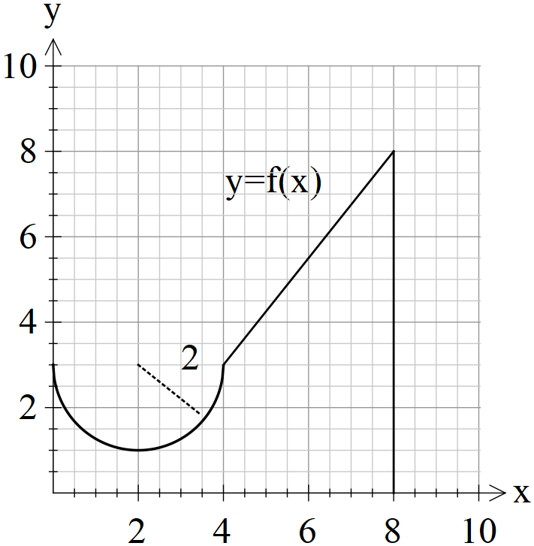

1. Determine the exact value of.
2. Determine to two decimal places such that 

Q4 (3.2.18-3.2.17) (3 & 2 = 5 marks)

A water tank has a leak and the volume of water contained, , can be described by the following differential equation at time,  minutes, . The tank is initially full but is emptied in 15 minutes.

1. Determine the initial volume of water in the tank.
2. Determine the change in volume in the third minute.

Q5 (3.2.11-3.2.14) (2, 2 & 2 = 6 marks)

Consider a function  that is defined for  with the following conditions.



With  for  and  for .

.

1. Determine .
2. Determine  given that .
3. Determine  when .

Q6 (3.2.20) (4 marks)

Determine to two decimal places the area between the curves  and .

(Hint- Sketch the curves first on your classpad)

Q7 (3.2.16) (1 & 3 = 4 marks)

Consider 

1. In terms of , express .
2. If  and , determine  in terms of  only.

Q8 (3.1.4) (4 marks)

A radioactive substance ZZZ initially has a mass of 230 grams and decays according to  where  equals the mass at time  minutes and  is a constant. After 6 minutes the mass is 176 grams. Determine the time taken for half the mass to decay(half-life) and the value of  to three decimal places.

Q9 (3.2.6) (2 & 4 =6 marks)

1. Determine .
2. Using your result from part (a) and **without using your classpad** determine .

**Working out space**

**Working out space**